

Capstone Project Report
Report 3 – Software Requirement Specification

– Hanoi, May 2026 –
Table of Contents
I. Record of Changes 3
II. Software Requirement Specification 4
1. Overall Requirements 4
1.1 Context Diagram 4
1.2 Main Workflows 5
1.3 User Requirements 5
1.4 System Functionalities 7
1.5 Entity Relationship Diagram 8
2. Use Case Specifications 9
2.1 <<Feature Name1>> 9
2.2 Common Feature 10
2.3 Xyz Feature 10
3. Functional Requirements 11
3.1 <<Feature Name1>> 11
3.2 System Administration 11
3.3 … 12
4. Non-Functional Requirements 12
3.1 External Interfaces 12
3.2 Quality Attributes 12
5. Requirement Appendix 13
5.1 Business Rules 13
5.2 System Messages 13
5.3 Other Requirements… 14

I. Record of Changes
Date | A*  M, D | In charge | Change Description
17/05 | A | DUNGPA | Add Use Case Specification
*A - Added M - Modified D - Deleted

II. Software Requirement Specification

1. Overall Requirements

1.1 Context Diagram
[Gives the overall description about the product with some introduction and the context diagram. The context diagram presents the boundary and connections between the system you’re developing and everything else in the universe. This identifies external entities (or terminators – software, hardware, human components, and other systems) outside the system that interface to it in some way, as well as data, control, and material flows between the terminators and the system.]
<<Sample: The Cafeteria Ordering System is a new software system that replaces the current manual and telephone processes for ordering and picking up meals in the Process Impact cafeteria. The context diagram below illustrates the external entities and system interfaces for release 1.0. The system is expected to evolve over several releases, ultimately connecting to the Internet ordering services for several local restaurants and to credit and debit card authorization services.
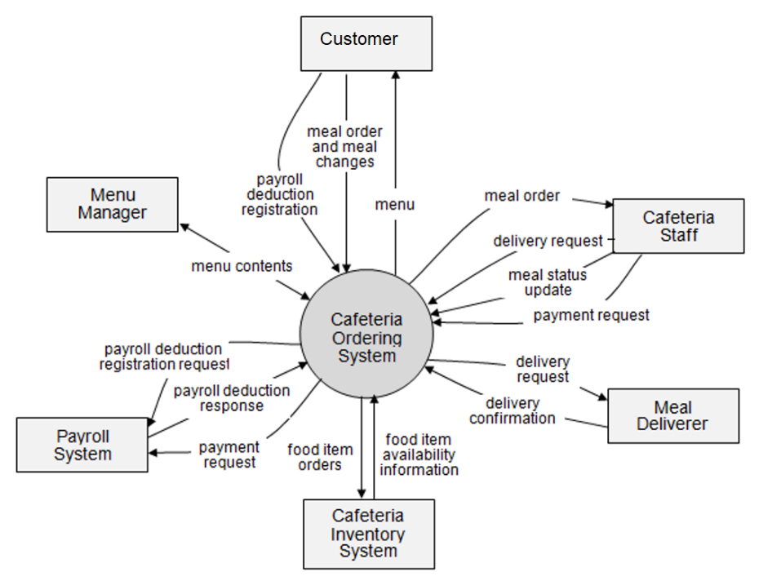
>>

1.2 Main Workflows
[Provide main workflows (business processes) using the swim-lane diagram(s) like sample below]

1.2.1 Order Processing
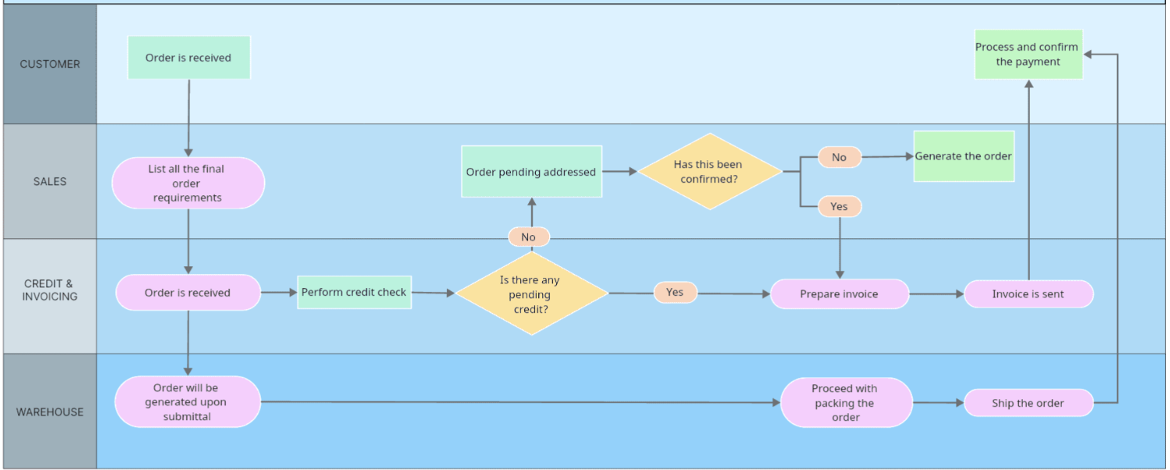

1.2.2 Customer Support
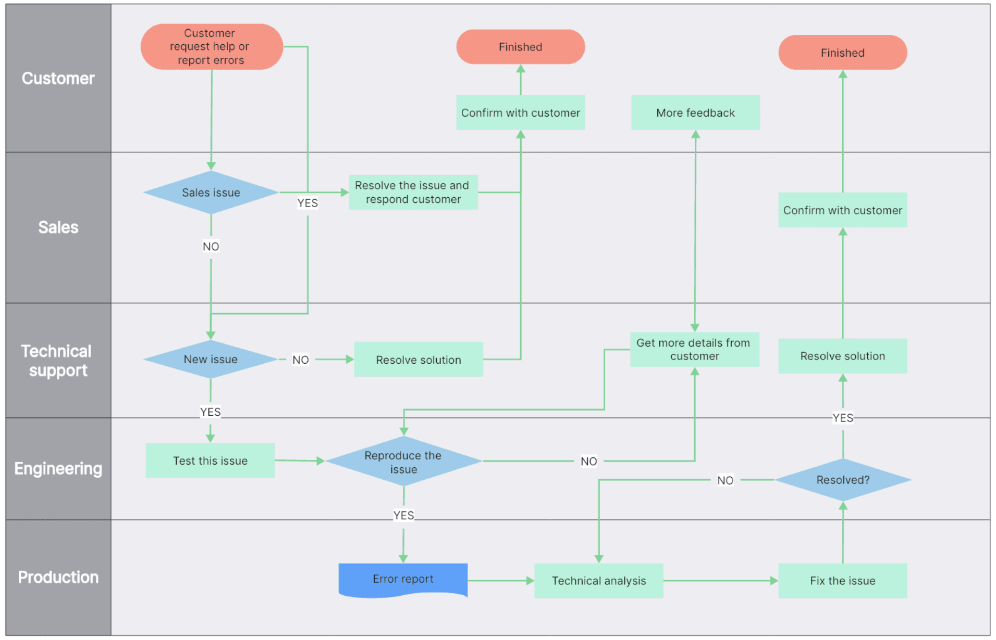

1.3 User Requirements

1.3.1 Actors
[An actor is someone/something that interacts with the system.
- The only external entities that interact with the system
- ﻿Actors are outside the system and not part of it
- ﻿A user is an individual, whereas an actor represents the role played by all users of the same type
- There are other types of actors in addition to or in place of human actors: external systems, I/O devices, or timers
Following are some questions you might ask to help user representatives identify actors
- Who (or what) is notified when something occurs within the system?
- Who (or what) provides information or services to the system?
- Who (or what) helps the system respond to and complete a task?
This part gives the description of system actors, you can follow the table form as below]
# | Actor | Description
1 | Administrator | Actor description here..
2 | Menu Manager | ..
3 | …

1.3.2 Use Cases
[A use case (UC) describes a sequence of interactions between a system and an external actor that results in the actor being able to achieve some outcome of value. The names of use cases are always written in the form of a verb followed by an object. Select strong, descriptive names to make it evident from the name that the use case will deliver something valuable for some user.
Following are some questions you might ask to help user representatives identify use cases
- What will the actor use the system for?
- Will the actor create, store, change, remove, or read data in the system?
- Will the actor need to inform the system about external events or changes?
- Will the actor need to be informed about certain occurrences in the system?
In this section, you need to provide the UC diagram(s) to show the actor-UCs and UC-UC relationships like the sample below. You can have multiple UC diagrams for the system, each diagram is for one actor or one workflow]

1.3.2.1 UCs for Guest
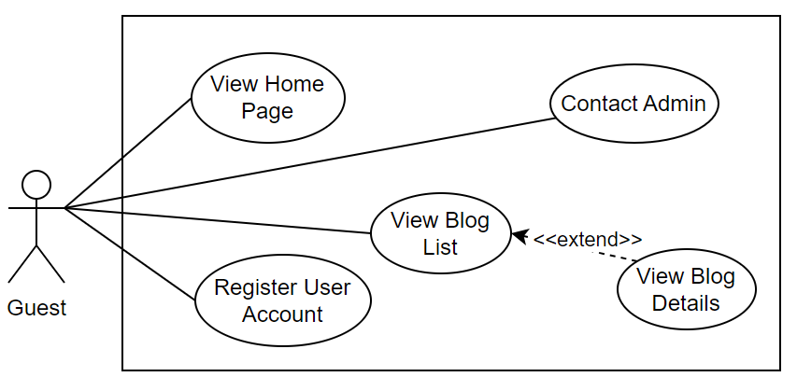

1.3.2.2 UCs for Student
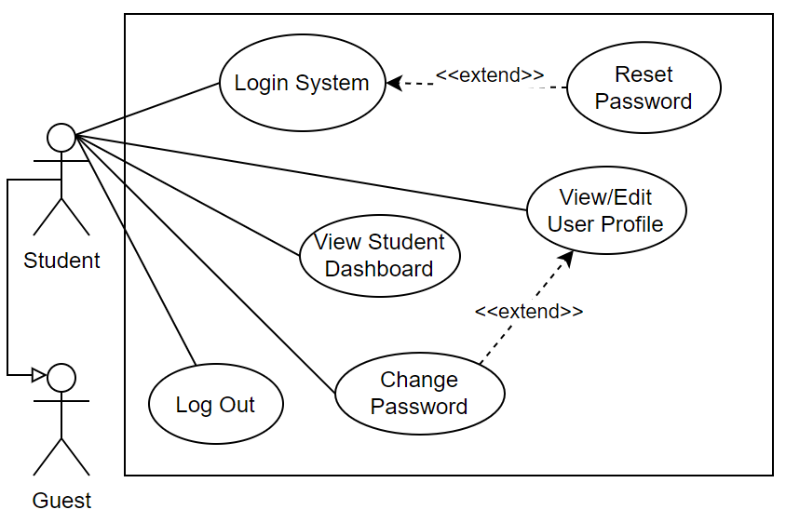

1.3.2.3 …

1.4 System Functionalities
[Provide functionality overview of software system: screen flow, screen descriptions, system user roles, screen authorization, non-screen functions, ERD]

1.4.1 Screens Flow
[This part shows the system screens and the relationship among screens. You can draw the Screens Flow for the system in the form of diagram as below.]
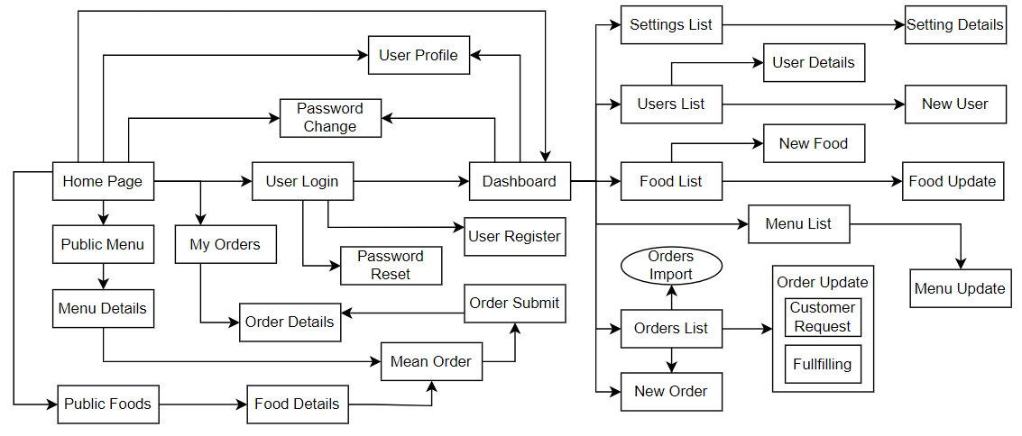

1.4.2 Screen Authorization
[Provide the system roles authorization to the system features (down to screens, and event to the screen activities if applicable) in the table form as below – replace Role1, Role2,… with your specific system user role names]
Screen | Role-Name1 | Role-Name2 | Role-Name3 | …
<<Screen Name1>> | X |  | X | X
<<Screen Activity>> |  |  | X | X
<<Screen Name2>> | X |  | X
Query All Data | X
Query Own Data |  |  | X
Add New Data |  |  | X | X
Update All Data |  |  |  | X
Update Own Data |  |  |  | X
Delete Data
…

1.4.3 Non-UI Functions
[Provide the descriptions for the non-screen system functions, i.e batch/cron job, service, API, etc.]
# | Feature | System Function | Description
1 | <<Feature Name>> | <<Function Name1>> | <<Function Name1 Description>>
2 | …

1.5 Entity Relationship Diagram
[Provide the entity relationship diagram and the entity descriptions in the table format as below]
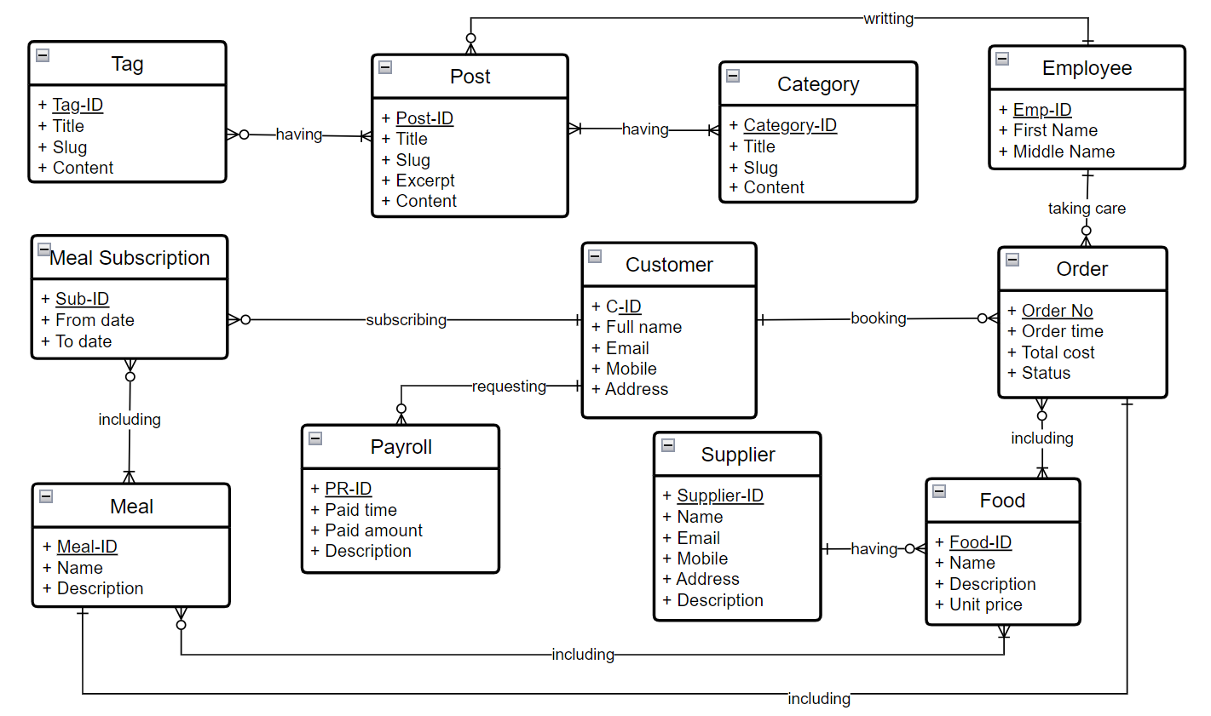

2. Use Case Specifications
[Provide specifications for the use cases (UCs) those are covered in the system. The UCs are grouped by the system features and even sub features. You just need to provide UC specifications for UCs involving in the main workflows (business processes) or the complex ones. Other UCs (i.e CRUD or data-viewing UCs) are simple, and you just need to refer the descriptions in the Functional Requirement (part 3) below)]

2.1 Connection and Session Lifecycle Management

2.1.1 UC-01: Network Connection and Identity Registration
Primary Actors | Client Node (Player) | Secondary Actors | Server Node
Description | Describes the process of a client establishing a physical TCP socket connection with the server and registering a unique player name to enter the active game lobby.
Preconditions | The Server Node application is active, listening on the designated TCP port, and ready to accept incoming physical socket connections.
Postconditions | - A stable, bi-directional TCP connection (Socket) is established  - Input/output streams are initialized  - The client's unique identity is registered in the server's active directory
Normal Flows | - Client Node initiates a TCP socket connection request to the Server Node's IP address and listening port.  - Server Node accepts the connection and spawns a dedicated worker thread (ClientHandler) to manage the communication lifecycle of this specific client.  - Client Node transmits an identity registration payload through its output stream: CONNECT <playerName>\n.  - Server Node reads the incoming stream, parses the packet, and validates the uniqueness of <playerName> within the server's active registry.  - Server Node registers the player, allocates a unique <assignedID>, and broadcasts a confirmation packet back to the client: CONNECTED <assignedID> <activePlayerList>\n.
Alternative Flows | UC-01-ALT-A: Duplicate Username or Server Capacity Exceeded  - At step 4, the Server Node detects that the <playerName> is already in use or the maximum player capacity is reached.  - Server Node sends a rejection packet: REJECT DUPLICATE_NAME\n or REJECT SERVER_FULL\n.  - Server Node safely terminates the physical connection, closes the I/O streams, and kills the associated ClientHandler thread.

Primary and Secondary Actors
An actor is a person or other entity external to the software system being specified who interacts with the system and performs use cases to accomplish tasks. Name the primary actor that will be initiating this UC and any other secondary actors who will participate in completing execution of the UC.
Description
Provide a brief description of the reason for and outcome of this use case, or a high-level description of the sequence of actions and the outcome of executing the use case. The description can be in the form of a user story (As a <type of user>, I want <some goal> so that <some reasons>)
Preconditions
List any activities that must take place, or any conditions that must be true, before the use case can be started.
Postconditions
Describe the state of the system at the successful conclusion of the use case execution.
Normal Flow
Provide a description of the user actions and corresponding system responses that will take place during execution of the use case under normal, expected conditions.
Alternative Flows
Describe below two information if any:
- Other successful usage scenarios that can take place within this use case. State the alternative flow, and describe any differences in the sequence of steps that take place.
- Any anticipated error conditions that could occur during execution of the use case and how the system is to respond to those conditions.

2.1.2 UC-06: Network Disconnection Exception Handling
Primary Actors | Server Node | Secondary Actors | Opponent Client
Description | Details how the server detects a network disconnection of a player, safely terminates associated resources, alerts the remaining opponent, and gracefully returns them to the lobby.
Preconditions | A game session is currently in the active PLAYING state.
Postconditions | - The failed socket connection is closed. Session memory on the server is freed  - The remaining player is safely reverted to the lobby state (LOBBY_IDLE).
Normal Flows | - Server Node detects a connection drop (e.g., intercepts an IOException or receives a null line during a socket read operation from Client A).  - Server Node terminates the execution of the ClientHandler thread associated with Client A and closes its physical TCP Socket.  - Server Node identifies Client B as the active opponent paired with Client A in the current game session.  - Server Node transmits an alert packet to Client B: OTHER_PLAYER_LEFT\n.  - Server Node destroys the active GameSession object, releases resources, and transitions Client B's state back to LOBBY_IDLE in the lobby registry.
Alternative Flows

2.2 Matchmaking and Challenge Coordination

2.2.1 UC-02: Game Invitation and Matchmaking
Primary Actors | Inviter Client | Secondary Actors | Server Node, Invitee Client
Description | Covers the matchmaking phase where an idle player sends a direct match invitation to another available player in the lobby, and the target player accepts the challenge to start a game.
Preconditions | Both client nodes have completed registration (UC-01) and are in the idle lobby state (LOBBY_IDLE).
Postconditions | - A game session (GameSession) is successfully instantiated on the server  - Both clients transition to the PLAYING state
Normal Flows | - Inviter Client transmits an invitation request packet: INVITE <inviteeID>\n to the server.  - Server Node intercepts the packet and verifies that the target <inviteeID> is online and currently in the LOBBY_IDLE state.  - Server Node forwards the invitation details to the target Invitee Client via its designated stream: INVITATION_FROM <inviterID> <inviterName>\n.  - Invitee Client receives the packet, processes the input, and transmits an acceptance packet: ACCEPT_INVITATION <inviterID>\n back to the server.  - Server Node locks the statuses of both clients to prevent other invitations, pairs their connection threads, and initializes a new game session.
Alternative Flows: | UC-02-ALT-A: Invitation Declined  - At step 4, the Invitee Client rejects the challenge and transmits a refusal packet: DECLINE_INVITATION <inviterID>\n.  - Server Node forwards a notification packet to the Inviter Client: INVITATION_DECLINED <inviteeID>\n.  - Both clients revert back to the LOBBY_IDLE state.  UC-02-ALT-B: Target Client Unavailable  - At step 2, the Server Node detects that <inviteeID> is non-existent or currently in a PLAYING state.  - Server Node replies to the Inviter Client with an error packet: REJECT INVITEE_UNAVAILABLE\n.

2.3 Gameplay and Authoritative Board Coordination

2.3.1 UC-03: Game Session Initialization and Role Assignment
Primary Actors | Server Node | Secondary Actors | Paired Client Nodes
Description | Describes the server-side initialization of a new game session, including board memory allocation, random symbol/turn assignment (X and O), and initial state synchronization.
Preconditions | Both clients have completed matchmaking (UC-02) successfully.
Postconditions | - Authoritative board array is initialized to empty  - Player symbols ('X' and 'O') are bound. Match state is synchronized
Normal Flows | - Server Node allocates a 1D array of 9 characters in memory to represent the 3x3 game board, initializing all elements to an empty char ' '.  - Server Node runs a random generator to determine which player is assigned the starting symbol 'X' (the player who goes first).  - Server Node assigns the symbol 'O' (the player who goes second) to the remaining client.  - Server Node simultaneously broadcasts the match configuration packets to both clients:  - To Client X: MATCH_START <opponentName> X\n  - To Client O: MATCH_START <opponentName> O\n.  - Server Node transmits a turn notification packet to Client X: TURN\n to prompt their first move.
Alternative Flows:

2.3.2 UC-04: Move Processing and Authoritative Validation
Primary Actors | Active Client | Secondary Actors | Server Node, Passive Client
Description | Governs the transmission of a player's move to the server, followed by the server's authoritative validation (turn, bounds, and cell availability) and subsequent state updates.
Preconditions | The game session status is PLAYING and the Server Node is waiting for input from the designated Active Client.
Postconditions | - Server Model is updated with the valid move  - Active turns are toggled  - Clients' interfaces are synchronized
Normal Flows | - Active Client captures the player's coordinate input from the console and transmits the move command: MOVE <locationIndex>\n (where <locationIndex> is an integer from 0 to 8).  - Server Node reads the command from the stream and runs authoritative validation checks :  - Turn validation: Verifies if the sending socket belongs to the player who currently holds the turn.  - Range validation: Checks if <locationIndex> is within the valid bounds (0 to 8).  - Cell validation: Checks if the cell in the Server's Model is currently empty (' ').  - Upon validation success, Server Node updates its authoritative board array with the player's mark.  - Server Node transmits a confirmation packet to the Active Client: VALID_MOVE\n.  - Server Node forwards a synchronization packet to the Passive Client: OTHER_PLAYER_MOVED <locationIndex>\n to update its console board.  - Server Node executes the terminal state check (UC-05). If the game continues, Server Node toggles the active/passive roles and transmits a TURN\n packet to the new active client.
Alternative Flows: | UC-04-ALT-A: Invalid Move or Out-of-Turn Command  - At step 2, one of the validation checks fails (e.g., cell already occupied, invalid index, or out-of-turn execution).  - Server Node rejects the move and transmits an error alert: MESSAGE INVALID_MOVE\n.  - Server Node re-transmits the TURN\n packet to the active client to prompt another coordinate input.

2.3.3 UC-05: Game Over Assessment and Match Rotation
Primary Actors | Server Node | Secondary Actors | Both Client Nodes
Description | Details how the server evaluates the board for terminal states (victory or draw), broadcasts the results, alternates player roles for the next match, and automatically triggers a rematch.
Preconditions | A valid move has been updated in UC-04, and the board state meets a terminal condition.
Postconditions | - Match outcomes are distributed  - Server board memory is cleared  - Player symbols are rotated  - A new game session starts automatically.
Normal Flows | - Server Node calculates the authoritative board state to check if a terminal condition has been reached :  - Win/Loss Condition: Three identical symbols are aligned horizontally, vertically, or diagonally.  - Draw Condition: All 9 cells are filled with no winning alignments.  - Server Node transmits the respective outcome packets to each socket :  - To the winning client: VICTORY\n  - To the losing client: DEFEAT\n  - To both clients (if a draw): TIE\n  - Server Node rotates player roles: the player who played as 'O' in the previous game is designated as 'X' (goes first), and the player who played as 'X' is designated as 'O' (goes second).  - Server Node resets the 1D board array in memory back to empty chars ' '.  - Server Node broadcasts the new match state and prompts the new 'X' player, repeating the execution flow from UC-03.
Alternative Flows:

3. Functional Requirements
[Provide descriptions about the system’s functions/screens. The functions/screens are grouped by the system features, and even sub-features if needed. For the screens, you need to provide the screen layouts (mock-up screens) and relevant specifications if needed]

3.1 <<Feature Name1>>

3.1.1 <<Screen/Function Name1>>
[Screen/Function description]
[Screen layout(s)]
[Screen specifications: field initializations, the showing/hiding of some fields, etc.]

3.1.2 User Login
This screen allows user to be authenticated to the system screens/functionalities.
S1_User Login screen | S2_Select account to login (with Google)
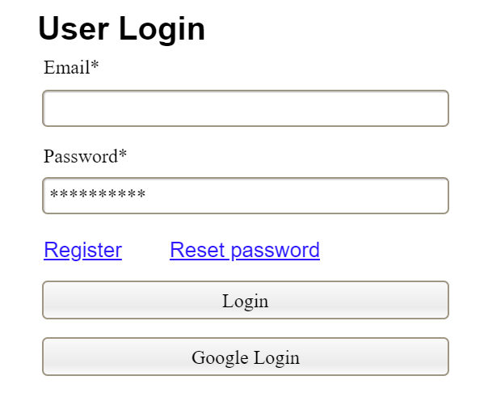 | 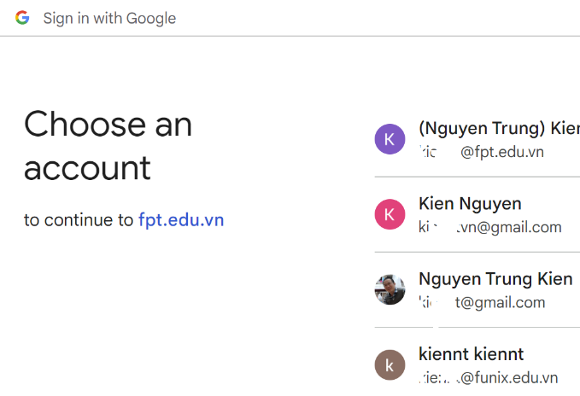

3.1.3 …

3.2 System Administration

3.2.1 System Settings

a. Setting List
This is for the administrator to view the list of current system settings. On the screen, s/he can also activate or deactivate (change status) of a specific setting.
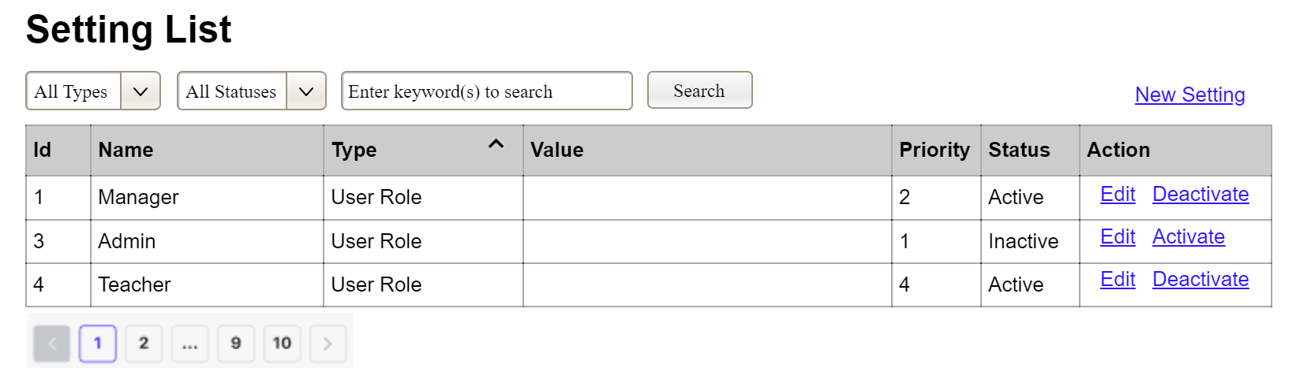
(2)
(3)
(1)
(1) Setting Type:
- Initialized with all the active setting types filled in,
- Allow user to filter the setting list by a specific setting type
- Default value is “All Types”, allowing user to see the settings at all types
(2) Setting Status:
- Initialized with two values Active and Inactive filled in
- Allow user to filter the setting list by a specific status (Active or Inactive)
- Default value is “All Types”, allowing user to see the settings at all statuses
(3) The change-status action is Activate or Deactivate depending on the current status of the relevant setting (Inactive or Active, respectively)

b. Setting Details
This is for the administrator to add new or view/update an existing system setting
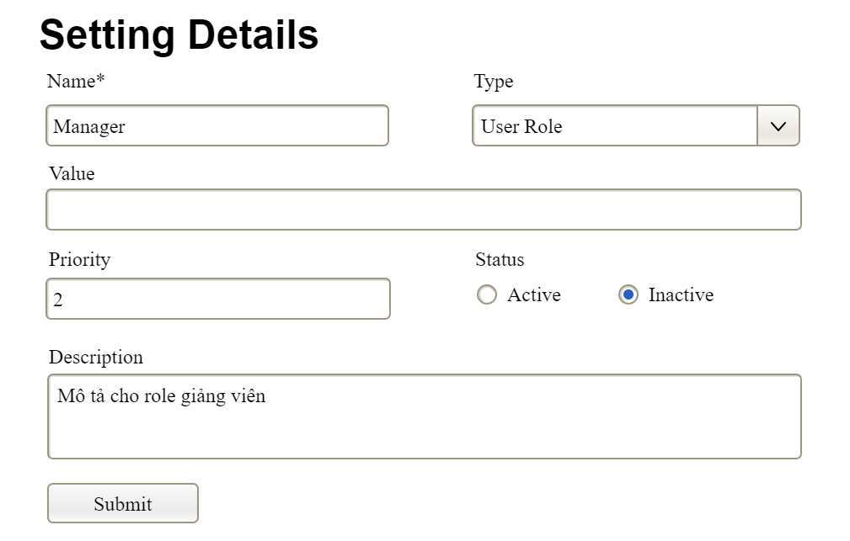

3.2.2 …

3.3 …

4. Non-Functional Requirements

3.1 External Interfaces
[This section provides information to ensure that the system will communicate properly with users and with external hardware or software/system elements.]

3.2 Quality Attributes
[List all the required system characteristics (quality attributes) specification. Some of the possible attributes are provided with the guide/descriptions are mentioned here]

3.2.1 Usability
[This section includes all those requirements that affect usability. For example, specify the required training time for a normal user and a power user to become productive at particular operations specify measurable task times for typical tasks or base the new system’s usability requirements on other systems that the users know and like specify requirement to conform to common usability standards, such as IBM’s CUA standards Microsoft’s GUI standards]

3.2.2 Performance
[The system’s performance characteristics are outlined in this section. Include specific response times. Where applicable, reference related Use Cases by name.
Response time for a transaction (average, maximum)
Throughput, for example, transactions per second
Capacity, for example, the number of customers or transactions the system can accommodate
Resource utilization, such as memory, disk, communications, and so forth.]

3.2.3 …

5. Requirement Appendix
[Provide business rules, common requirements, or other extra requirements information here]

5.1 Business Rules
[Provide common business rules that you must follow. The information can be provided in the table format as the sample below]
ID | Rule Definition
BR-01 | Delivery time windows are 15 minutes, beginning on each quarter hour.
BR-02 | Deliveries must be completed between 10:00 A.M. and 2:00 P.M. local time, inclusive.
BR-03 | All meals in a single order must be delivered to the same location.
BR-04 | All meals in a single order must be paid for by using the same payment method.
BR-11 | If an order is to be delivered, the patron must pay by payroll deduction.
BR-12 | Order price is calculated as the sum of each food item price times the quantity of that food item ordered, plus applicable sales tax, plus a delivery charge if a meal is delivered outside the free delivery zone.
BR-24 | Only cafeteria employees who are designated as Menu Managers by the Cafeteria Manager can create, modify, or delete cafeteria menus.
BR-33 | Network transmissions that involve financial information or personally identifiable information require 256-bit encryption.
BR-86 | Only regular employees can register for payroll deduction for any company purchase.
BR-88 | An employee can register for payroll deduction payment of cafeteria meals if no more than 40 percent of his gross pay is currently being deducted for other reasons.

5.2 System Messages
# | Message code | Message Type | Context | Content
1 | MSG01 | In line | There is not any search result | No search results.
2 | MSG02 | In red, under the text box | Input-required fields are empty | The * field is required.
3 | MSG03 | Toast message | Updating asset(s) information successfully | Update asset(s) successfully.
4 | MSG04 | Toast message | Adding new asset successfully | Add asset successfully.
5 | MSG05 | Toast message | Confirming email of asset hand-over is sent successfully | A confirmation email has been sent to {email_address}.
6 | MSG06 | Toast message | Resetting asset information successfully | Return asset(s) successfully.
7 | MSG07 | Toast message | Deleting asset information successfully | Delete asset(s) successfully.
8 | MSG08 | In red, under the text box | Input value length > max length | Exceed max length of {max_length}.
9 | MSG09 | In line | Username or password is not correct when clicking sign-in | Incorrrect user name or password. Please check again.
10 | ..

5.3 Other Requirements…

